Appendix V

The STARD Checklist for the reporting of studies of Diagnostic Accuracy
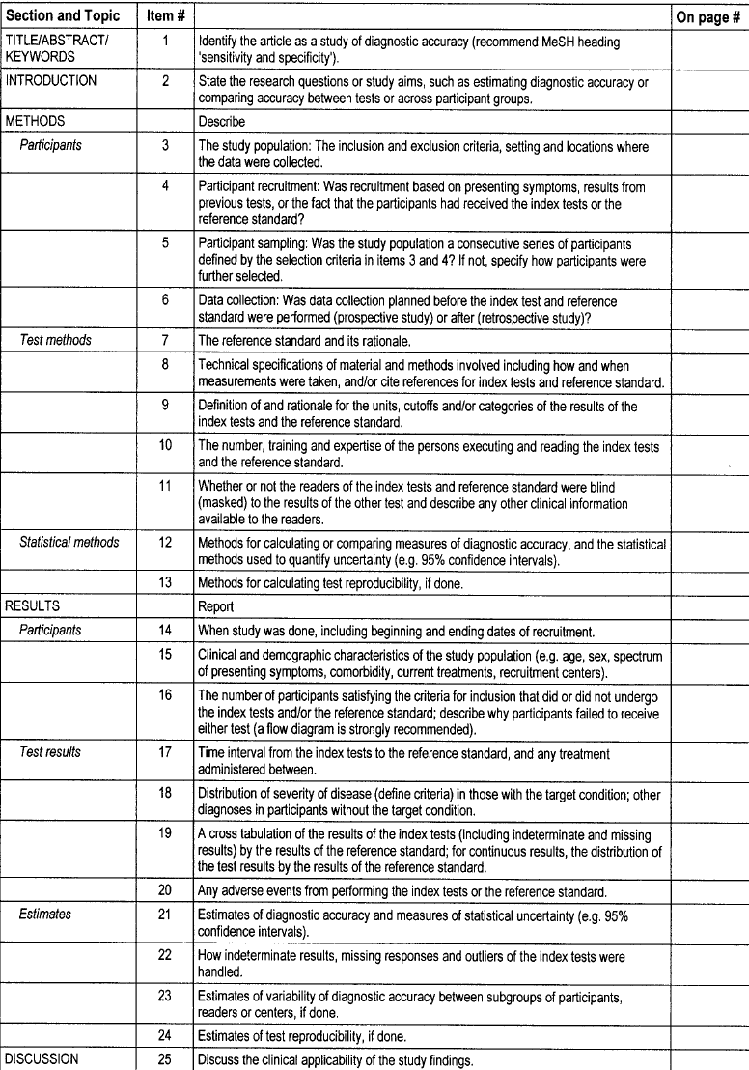

From Bossuyt et al.: The STARD Initiative. Clinical Chemistry 2003; 49: 1–6

Flow diagram of a diagnostic accuracy study (prototype)

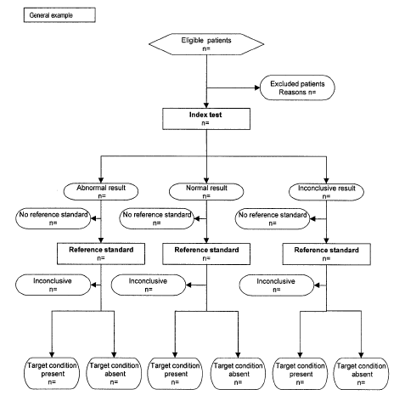

Note: For studies with other designs, see the STARD website
(www.consort-statement.org.htm)

