DSMB Report Template

-Open Session-

Title Page

(Title of the Study, PI)

Table of Contents
Title Page i
Table of Contents ii
Report Summary 1
Protocol Synopsis 2
Project Organizational Chart, Personnel 2
Brief Statement of Purpose of Trial 2
Projected Timetable and Schedule 2
Narrative/Trial Summary 3
Study Status 3
Summary of Past DSMB Meetings 3
Action Items 3
Resolution of Action Items 3
Summary of Protocol Changes 3
Recruitment and Participant Status: Figures and Tables 4
Figure 1: Overall Study Status 5
Table 1: Participant Enrollment Status 6
Table 2: Reasons for Screen Failures 7
Table 3: Protocol Deviations 8
Table 4: Demographic and Key Baseline Characteristics 9
Table 5: Treatment Duration for All Participants 10
Safety Assessments for All Participants: Tables and Listings 11
Table 6: Incidence of Adverse Events by Body System and Preferred Term 12
Table 7: Severity of Adverse Events by Preferred Term 13
Listing 1: Serious Adverse Events 14
Listing 2: Deaths 15
Listing 3: Adverse Events 16
Table 8: Laboratory Test Results Summary 17
*The final format of the reports, tables, and listings are to be determined by the Data and Safety Monitoring Board.

Report Summary

Protocol Synopsis

Project Organizational Chart, Personnel

Brief Statement of Purpose of Trial

Projected Timetable and Schedule

Narrative/Trial Summary

Study Status

Summary of Past DSMB Meetings

Action Items

Resolution of Action Items

Summary of Protocol Changes

Study Administration

Recruitment and Participant Status:

Figures and Tables

Figure 1: Overall Study Status

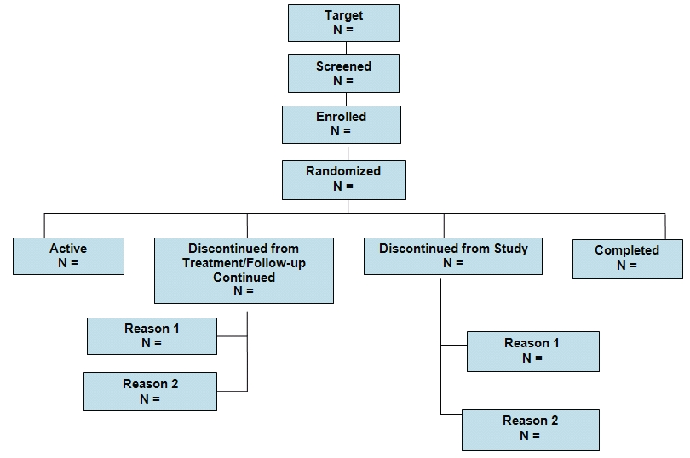
Data as of:
Date of report:
Recruitment Start Date:

Table 1: Participant Enrollment Status

Data as of:_________

Date of report:_________

 | N | %
Enrolled |  | 100
Active
Completed
Discontinued Treatment/Follow-up Continued |  | 100
Personal Reason
Serious Adverse Event/ AE
Discontinued from Study |  | 100
Lost to follow- up
SAE/AE
Withdrew Consent

- These are examples. Use categories relevant to protocol.

Table 2: Reasons for Screen Failures

Data as of:_________

Date of report:_________

Reason | Total N | Total %*
Total Screened
Total Screen Failures

* - % of the total number screened

Table 3: Protocol Deviations

Data as of:_________

Date of report:_________

 | Protocol Deviation* | Total | Since Last DSMB Report
1
2
3
4
5
6
 | Total # of Deviations
 | Participants Enrolled
 | Deviations per Participant

*Possible deviations may include:
- Did not meet inclusion/exclusion criteria
- Visit noncompliance/incomplete visit
- Participant taking concomitant drugs which are not allowed
- Assessments outside protocol window
- Failure to obtain informed consent

Table 4: Demographic and Key Baseline Characteristics

Data as of:_________

Date of report:_________

Characteristics |  | N (%)
Total Enrolled:
Gender | Male
Gender | Female
Clinical Features/  Stratification | BMI ≥ 30*
Age | Mean
Age | Median
Age | Standard Deviation
Age | Minimum
Age | Maximum

* This is an example, needs to be protocol specific.

Table 5: Treatment Duration for All Participants

Data as of:_________

Date of report:_________

Time in Study*  Total N= | n | %
Visit 1
Visit 2
Visit 3
Visit 4
Completed Study

* Needs to be protocol specific and can be shown by visits, days, weeks, months, or treatment periods. Final format is determined by DSMB.

Safety Assessments for All Participants:

Tables and Listing

Table 6: Incidence of Adverse Events by Body System and Preferred Term

Data as of:_________

Date of report:_________

Body System and Preferred Term | Total N=n* | Total N= (%)** | Total N=Events***
Overall
Cardiovascular
Myocardial Infarction
Increased Blood Pressure
etc.
Genitourinary
Yeast Infection
Vaginal Bleeding
etc.
Gastrointestinal
etc…

* Number of participants experiencing an adverse event (participant is to be counted only once for each adverse event)
** % of total number of participants in the study
*** Number of events
This table can present overall incidence of adverse events as shown above; or adverse events related to the intervention as judged by the investigator; or treatment emergent events.

Table 7: Severity of Adverse Events by Preferred Term
Data as of:_________

Date of report:_________

Preferred Term* | Total N=Mild n** (%)*** | Total N=Moderate n (%) | Total N=Severe n (%)
Headache
Pain
etc.

* For each preferred term, sort by most common event in descending order of incidence
** Number of participants experiencing a certain severity of an adverse event where each participant is counted only once at the highest level of severity for the event
*** % of participants experiencing a certain severity of an adverse event

This table can present severity of all adverse events sorted by preferred term in descending order of incidence as shown above; or adverse events related to the intervention as judged by the investigator; or treatment emergent events.

Listing 1: Serious Adverse Events

Data as of:_________

Date of report:_________

Participant ID | Onset Date | Stop Date | Expected  (Y/N) | Relationship to Intervention*  (Y/N) | Outcome** | Description of SAE

* Definite, Possible, Not Related
** Outcome:
Recovered, without treatment
Recovered, with treatment
Still Present, no treatment
Still Present, being treated
Residual effect(s) present – no treatment
Residual effect(s) present- being treated
Subject died

Participant ID | Date of Death | Cause of Death | Relationship to Intervention*

Listing 2: Deaths

Data as of:_________

Date of report:_________

* Definite, Possible, Not Related

Listing 3: Adverse Events *
Data as of:_________

Date of report:_________

Participant ID | Days on Intervention | Preferred Term | Relationship to Intervention** | Severity | Serious (Y/N) | Outcome***

* This listing could be provided in two ways – sorted by Preferred Term or sorted by Participant ID.
** Definite, Possible, Not Related
*** Outcome:
Recovered, without treatment
Recovered, with treatment
Still Present, no treatment
Still Present, being treated
Residual effect(s) present – no treatment
Residual effect(s) present- being treated
Subject died

Table 8: Laboratory Test Results Summary*
Data as of:_________

Date of report:_________
Laboratory Test | Sample Study Visits | N | Mean | SD | Min | Median | Max | N | Mean | SD | Min | Median | Max
Test 1 | Screening
 | 6 Months
 | 12 Months
 | 24 Months
 | 36 Months
Test 2 | Screening
 | 6 Months
 | 12 Months
 | 24 Months
 | 36 Months
Etc… | Screening
 | 6 Months
 | 12 Months
 | 24 Months
 | 36 Months
---------------Change from Baseline--------------
* Table may include lab test results that are clinically significant, as defined by the protocol, or ALL lab test results. Final format is determined by the DSMB.

